Assignment AWS 3:

Task 1
Create a linux t2.micro ec2 instance. After logging into this instance move /etc/sudoers file with /etc/sudoers.bkp
Now try to login, If can't - resolve this issue

Solution:

- Create an instance namely hemant
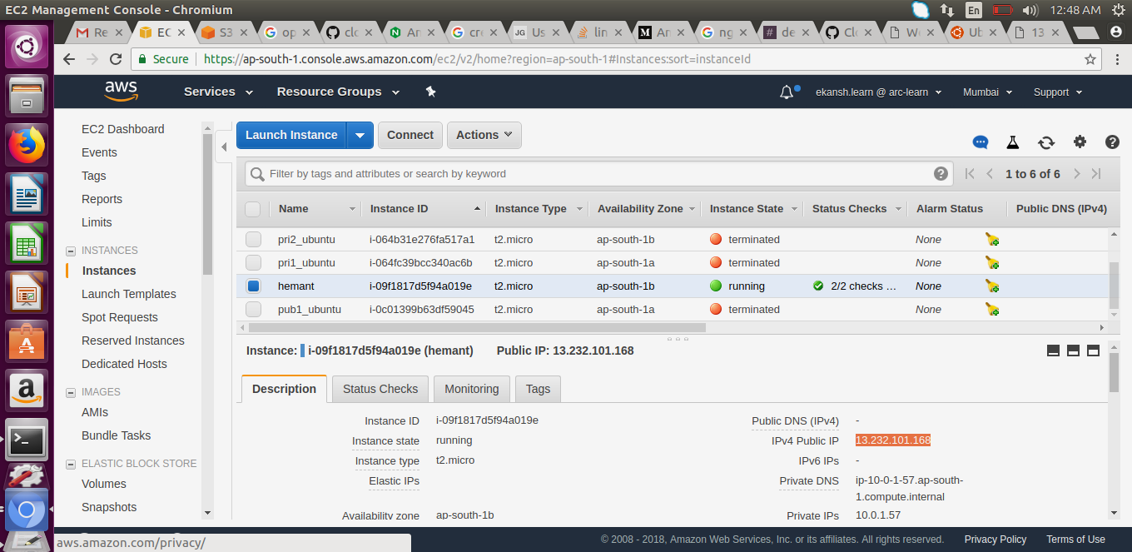
ii. Login into that instance using
ssh -i "ninjakey.pem" ubuntu@13.232.130.85
iii. Go to /etc/
sudo mv sudoers /etc/sudoers.bkp
iv. Now sudo commands will not run
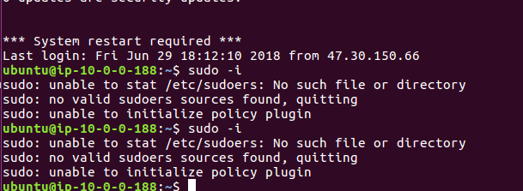
v. To fix it
- stop this instance and detach its volume
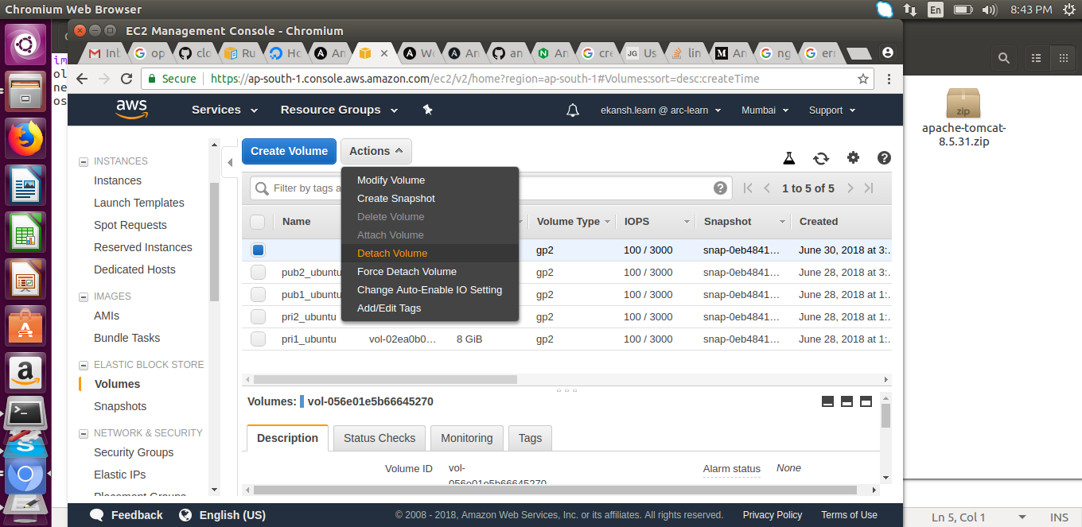

ii. Now create a new instance or used old one, detach its volume similarly.
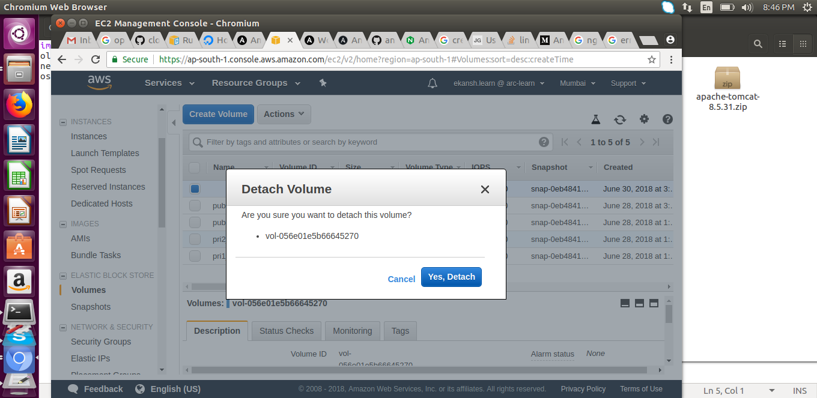
Iii. Attach this volume to instance “hemant” to get sudoers file back
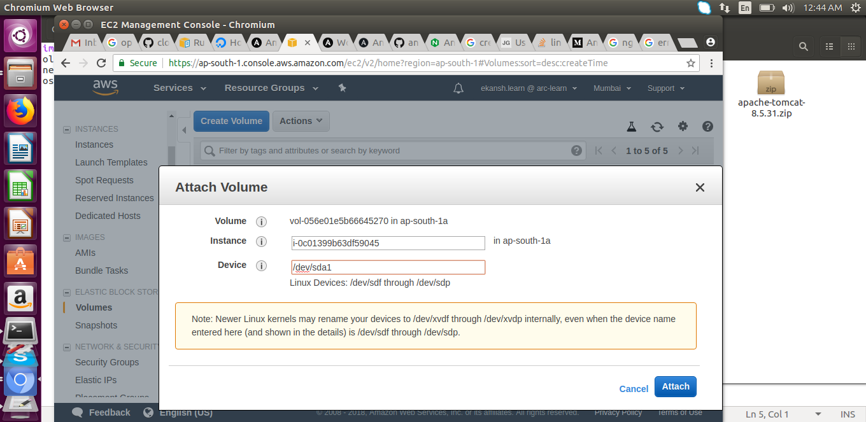
iv. now sudo command can be run

Task 2
create an ansible role before pushing the same to your public github repository.
This Role will simply host an nginx webpage saying
- "Hi i am ninja and my name is {yourname}"
Execute this role in user data script while launching another instance
Your website should be up & running after the system boots up
tag this instance as ninja:yourname

Solution:

i. Created a bucket namely ansibleplaybooks on s3 and upload nginx playbook to it (keeping the file to be publicly accessible)
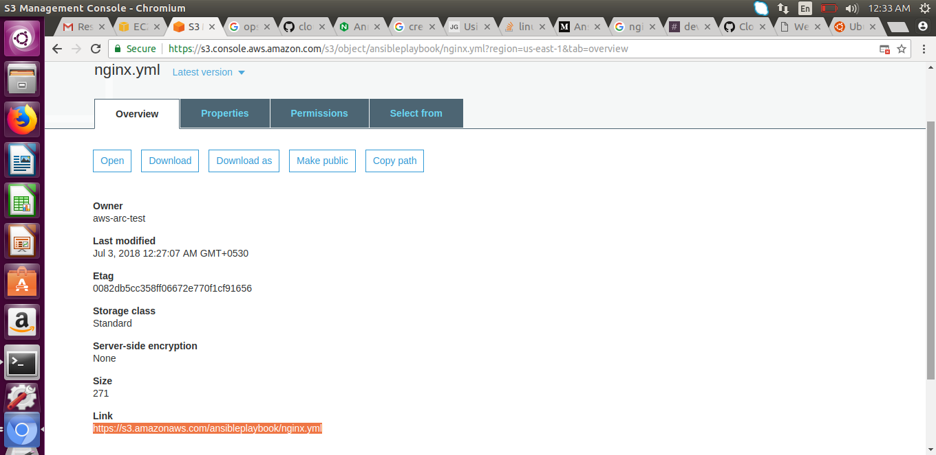
ii. Created a file index.html and uploaded in on s3 keeping properties as publicly accessible that says “hi i am ninja and my name is hemant khokhar”
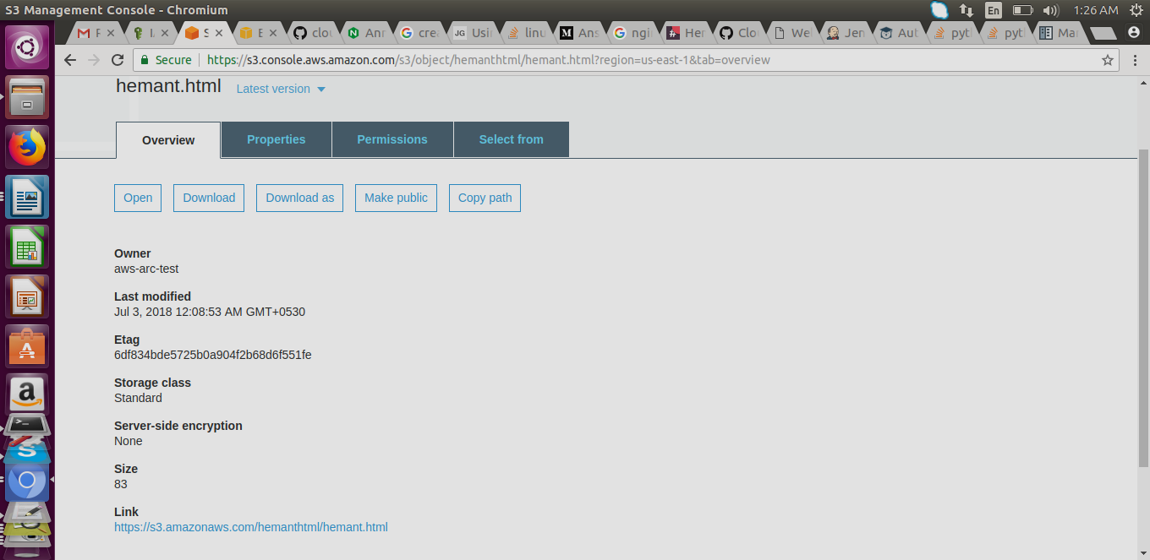

iii. Created a instance namey “hemant” and enter the following into its userdata

#!/bin/bash
sudo apt-get update -y
sudo apt-get install software-properties-common -y
sudo apt-add-repository ppa:ansible/ansible -y
sudo apt-get update -y
sudo apt-get install ansible -y
sudo mkdir ansible
cd ansible
sudo wget https://s3.amazonaws.com/hemanthtml/hemant.html
sudo wget https://s3.amazonaws.com/ansibleplaybook/nginx.yml
sudo ansible-playbook nginx.yml
sudo mv hemant.html /var/www/html/index.nginx-debian.html
sudo systemctl restart nginx
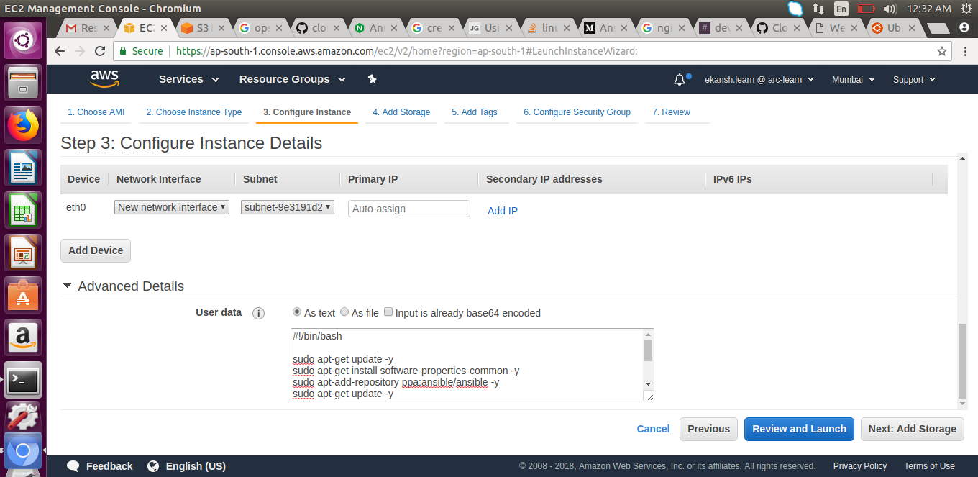
iv. Copy its DNS address and run on a browser we get
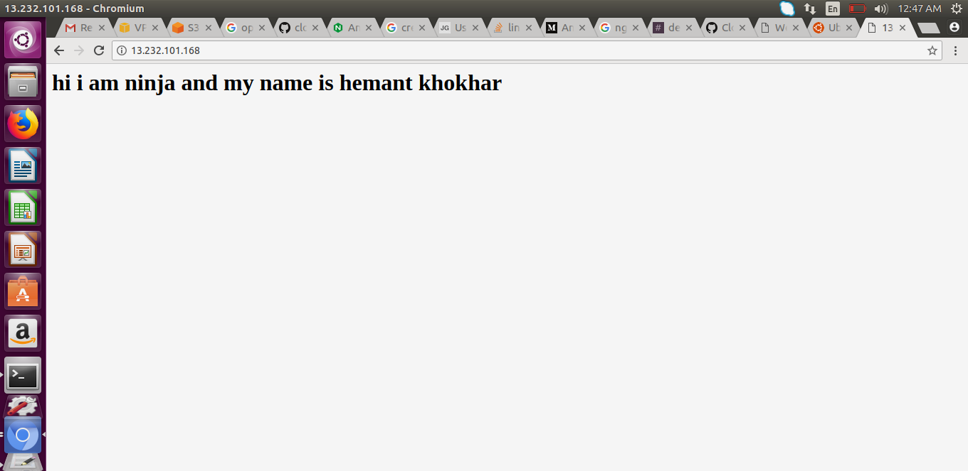

Task 3
write a jobDsl to start stop this instance through jenkins

Solution:
- Created a ima user namely ekansh_test and privide the EC2 full role and provide programatic access
- Creat access and secret keys
- Install jenkins on the base machine
- install awscli in the base machine
- now switch to jenkins user using:
sudo su jenkins
- Configure aws on jenkins server using
aws configure
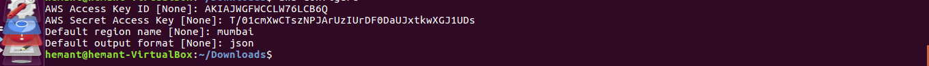
vi. Created the job dsl to start and stop instance

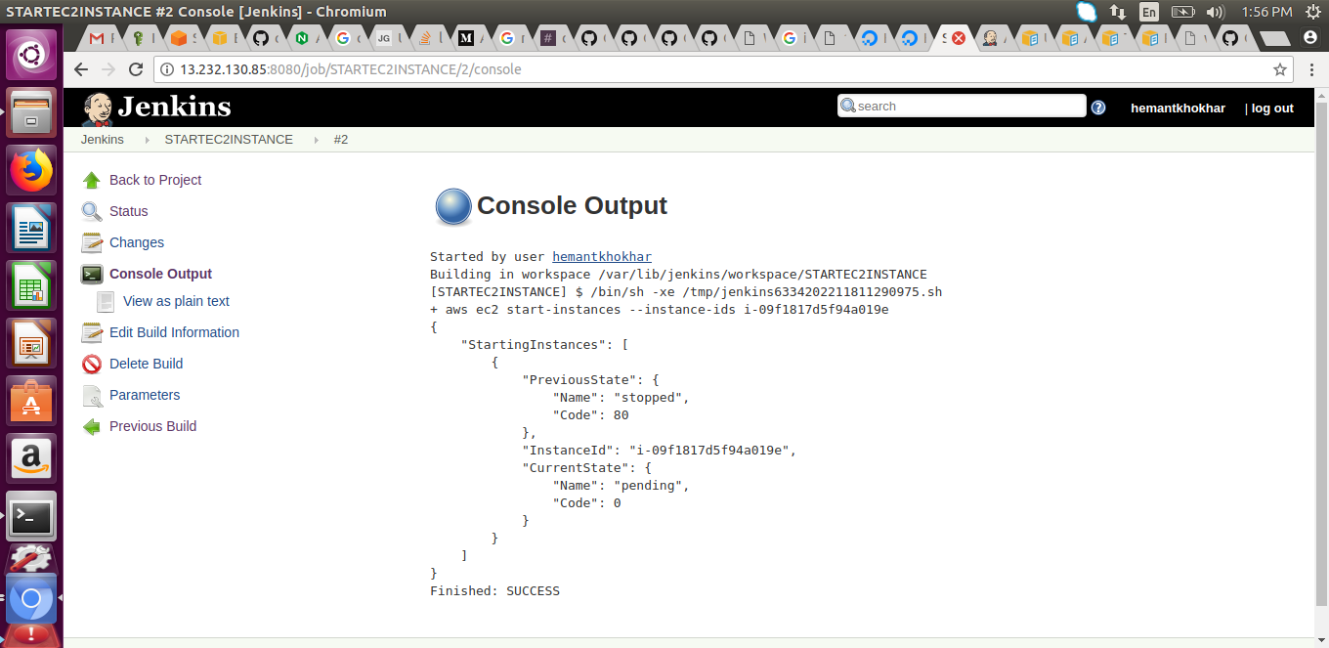

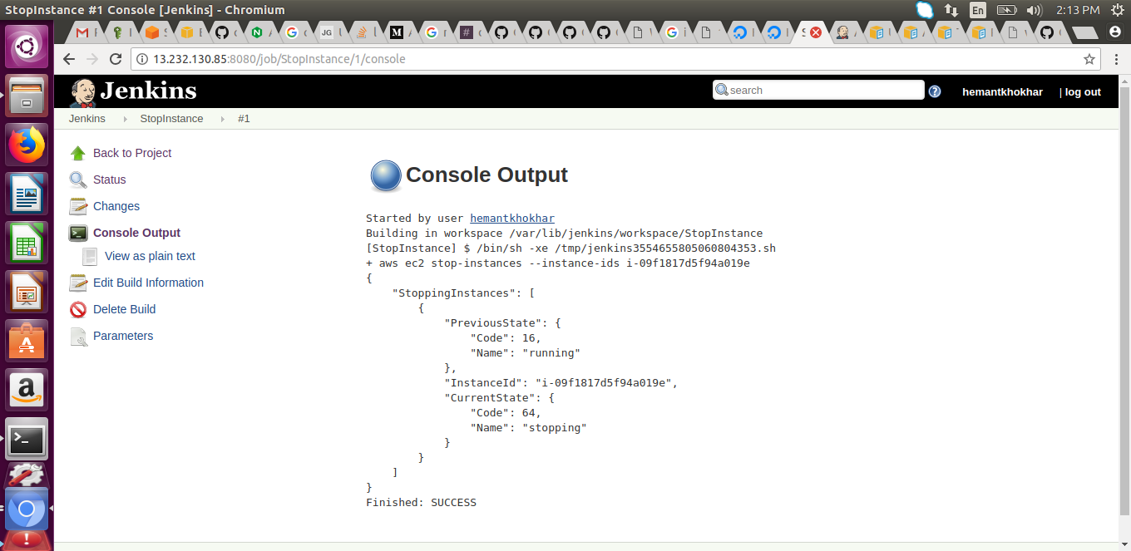

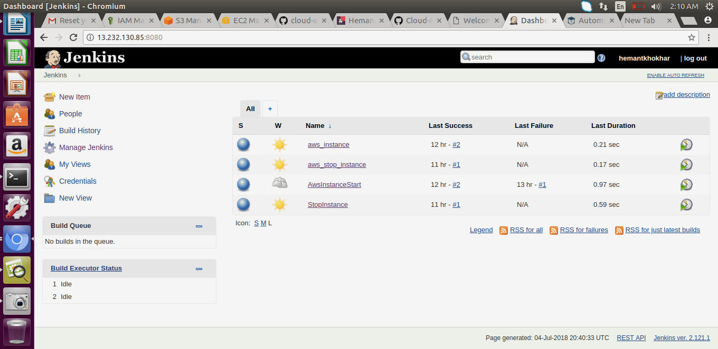
vii. Build the job with parameters (instance id)

